Statement of Applicant

The self-evaluation report must end with the following declaration:

I (full name, position as head of the institution/department/faculty responsible for the study programme) hereby agree that this (institution/department/faculty) will, if awarded the Eurolabel®, recognise equivalent degrees in chemistry awarded by other institutions holding the Eurolabel® as providing automatic right of access (but not of admission) to higher educational or qualification programmes offered by this (institution/department/faculty).

I hereby agree that this (institution/department/faculty) will, if awarded the Eurolabel®, display the official Eurolabel® logo on the website of this (institution / department / faculty) and remove this label from the website as soon as the validity term of the awarded Eurolabel® expired.

I hereby authorise ECTN to archive the information provided as well as to use it (without giving the source) to further scientific, statistical, promotional, and educational use.

I agree that the Self-Evaluation report together with the Site Visit Report will be published on the ECTN website in case the label is awarded.

It must also be signed, (stamped) and dated by the person making the declaration.

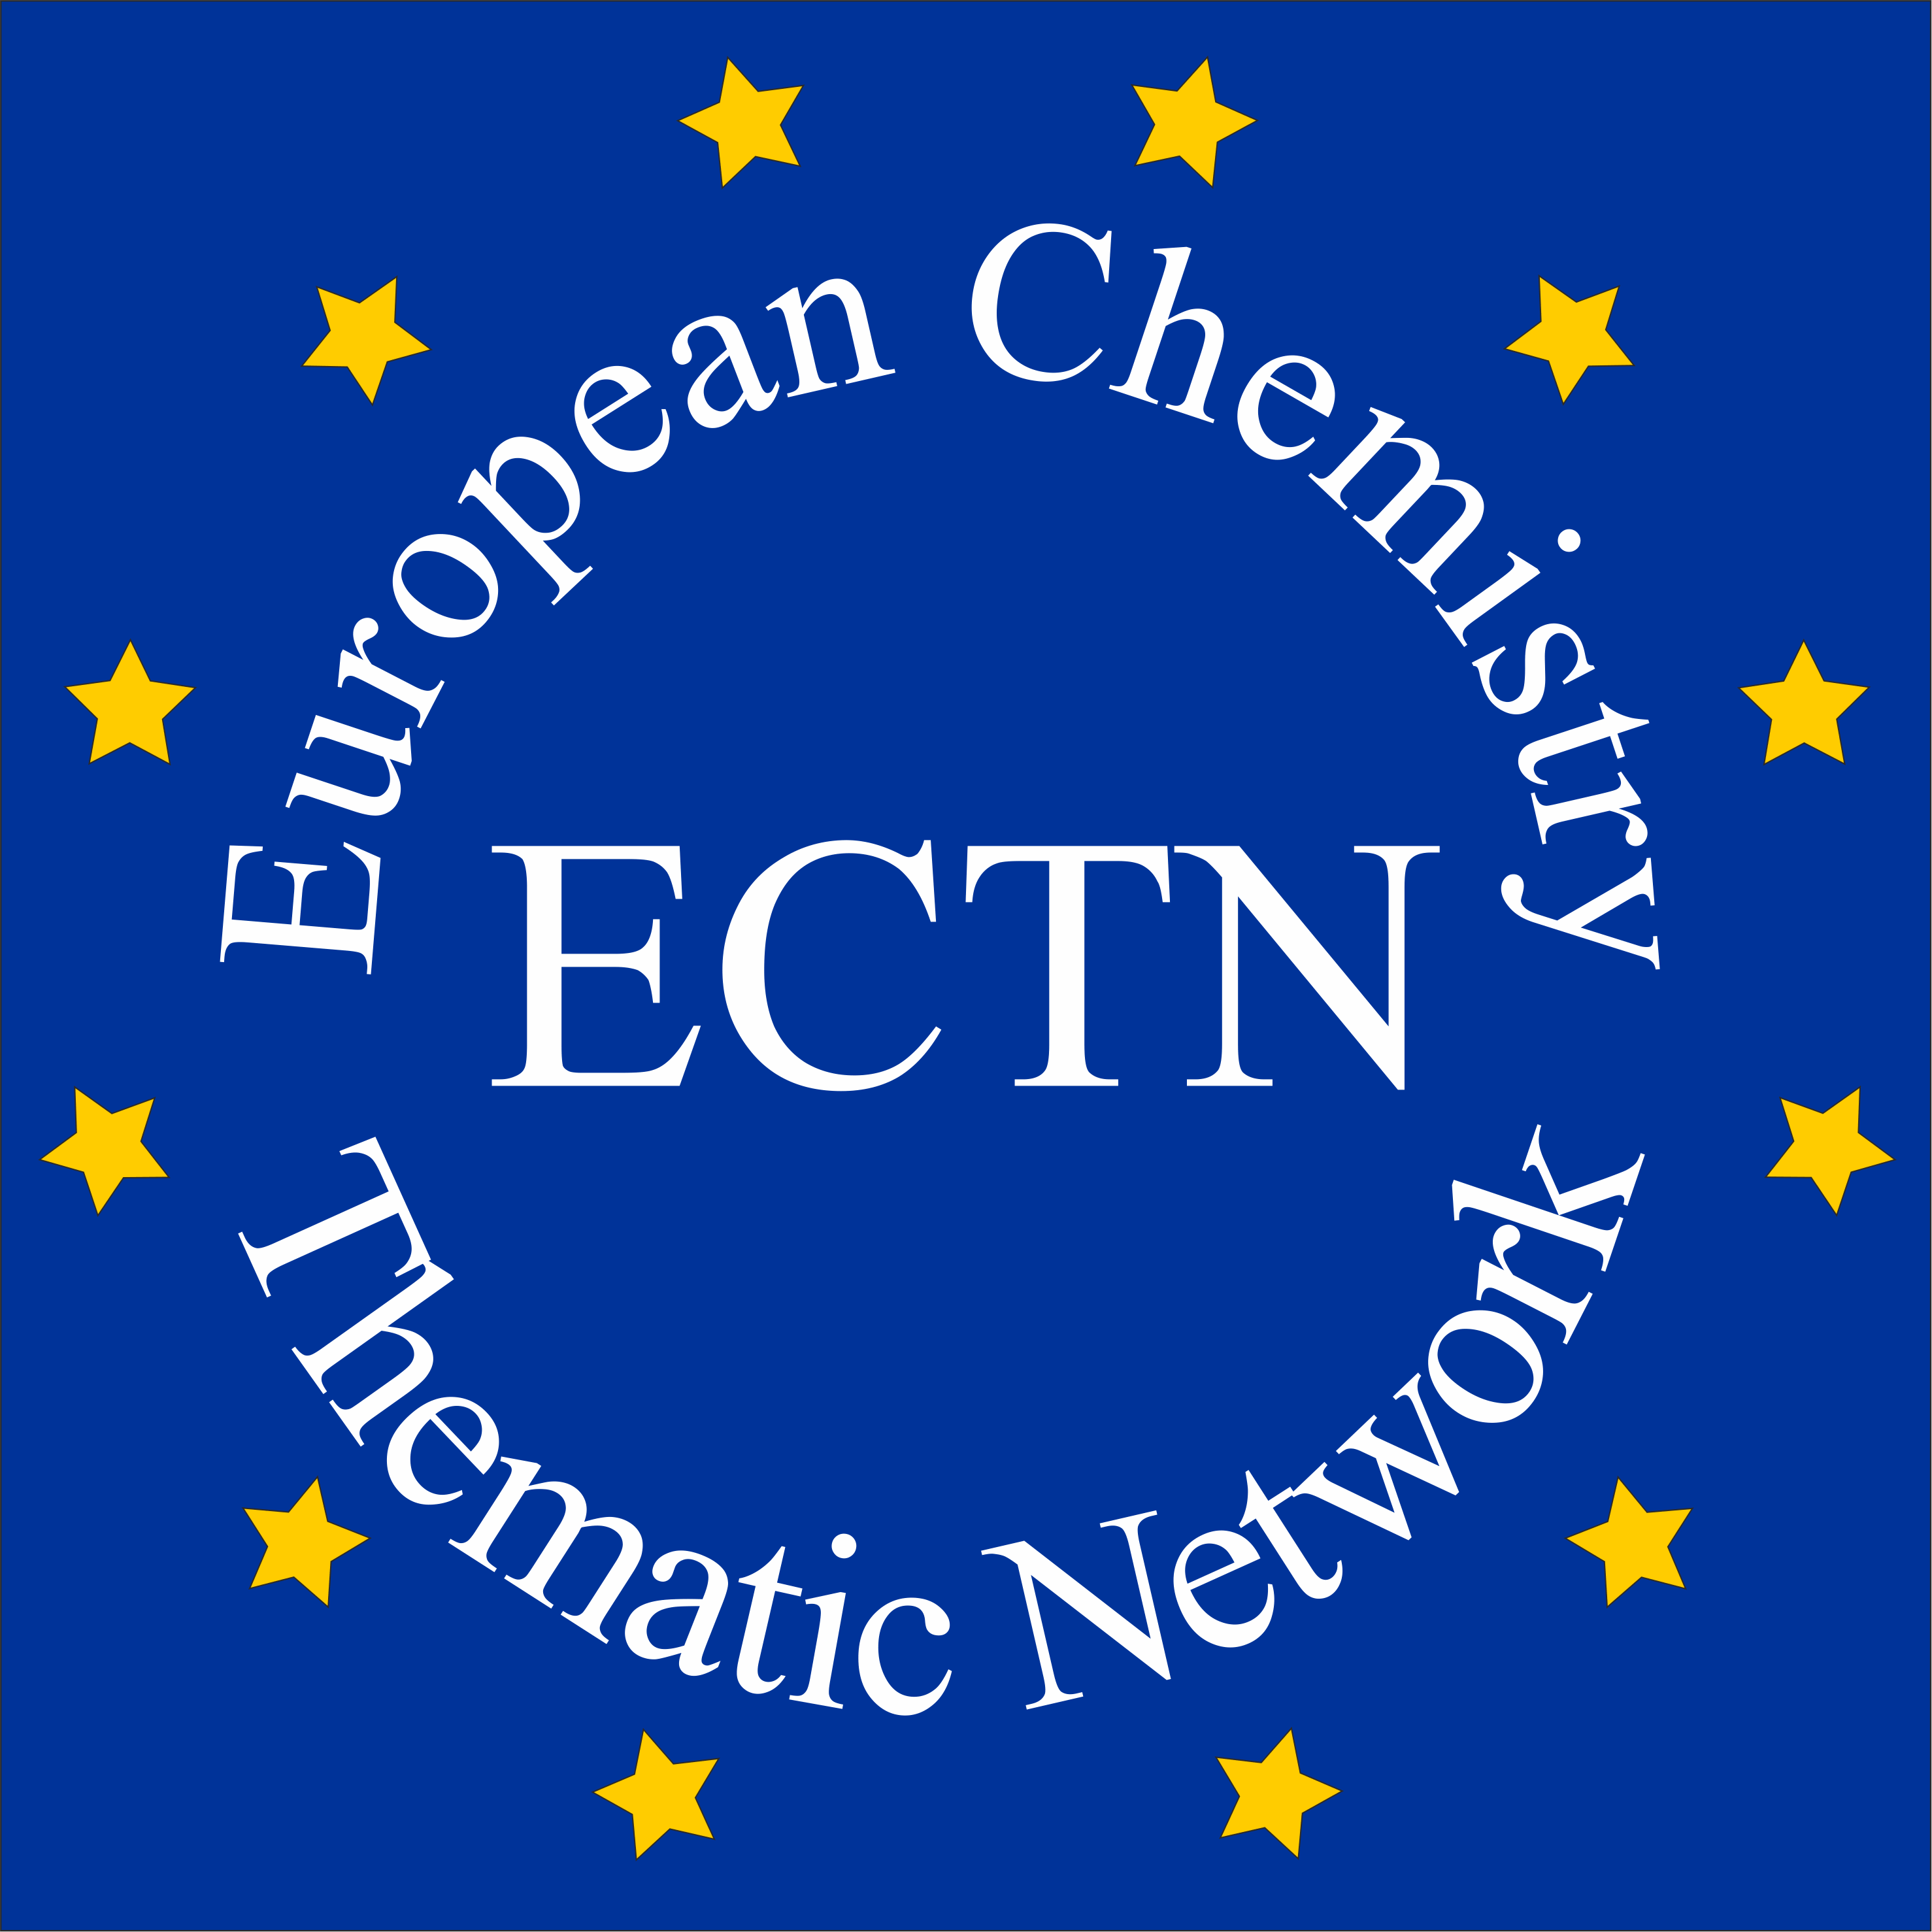 | Student Mobility Database | 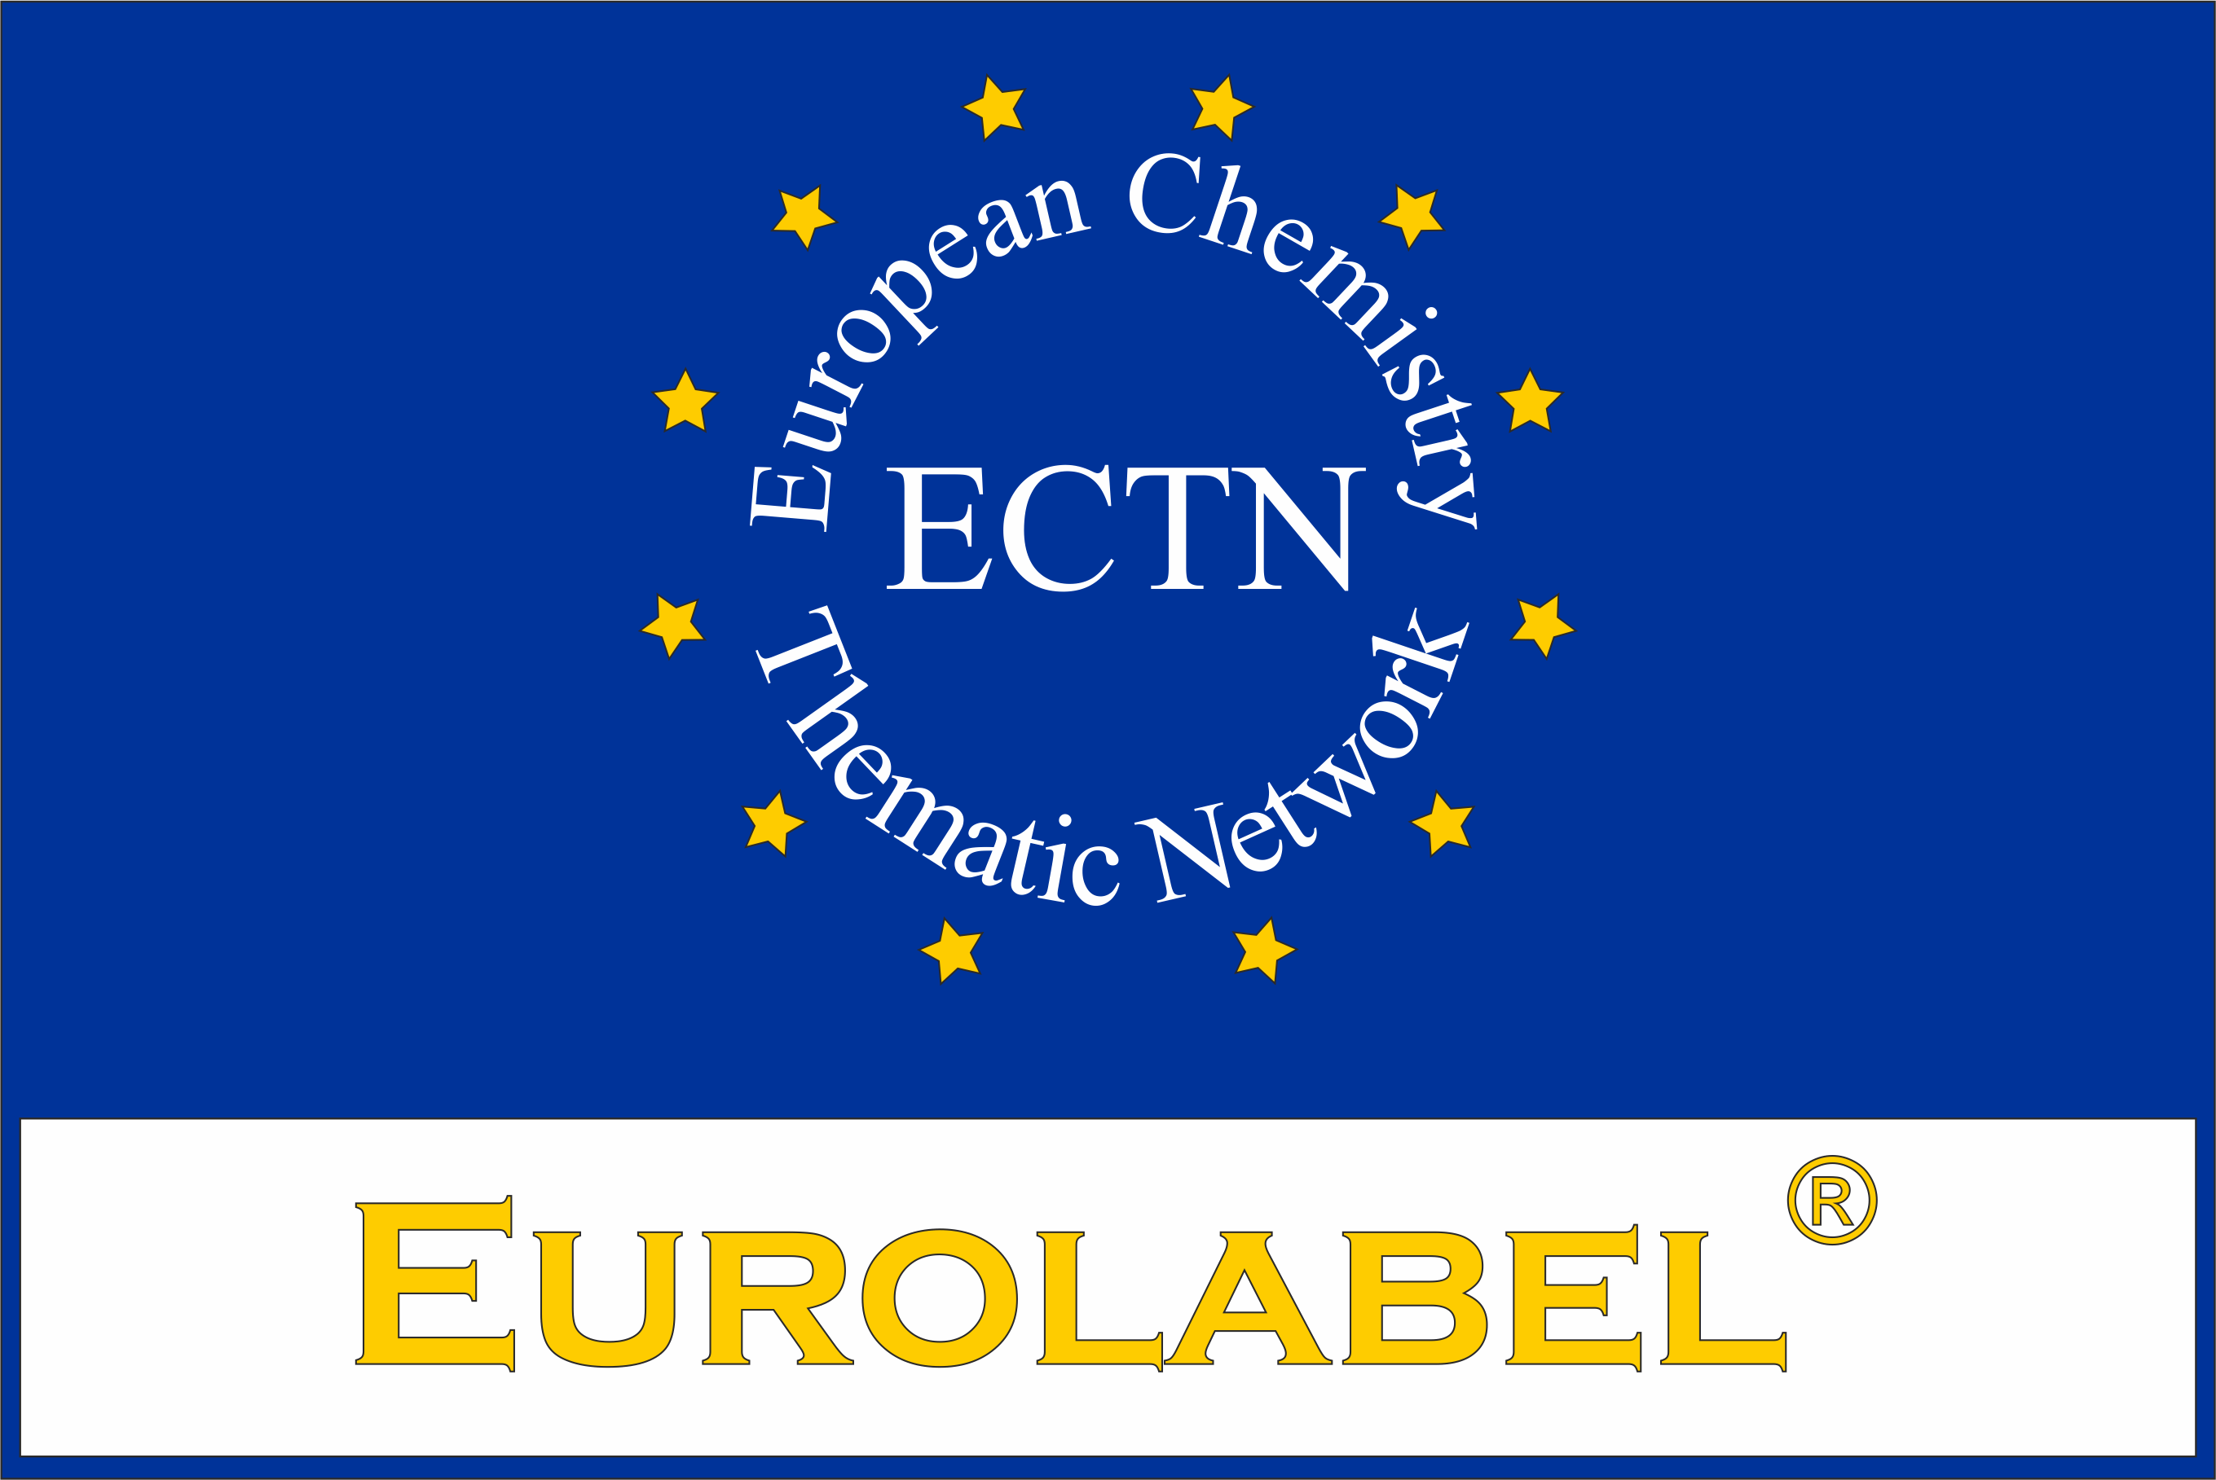
Table to be filled in on each programme that is submitted to Eurolabel® application. Data contained in the table will be used by ECTN and published on http://ectn.eu/mobility/. By submitting the data the responsible authorities of the respective university agree with data basing and publication.

Institution (& ERASMUS Code) | English name of the institution | ERASMUS Code
 | Name of the institution in the original language
Faculty/Department | Name of the faculty or department
Qualification awarded (& ERASMUS Subject Area Code) | Title of the qualification awarded | ERASMUS Subject Area Code
Level of qualification (Bologna & EQF) | Level of Qualification (Bologna) | Number of EQF  (ex: 6 for EQF6)
Name of qualification (programme) | In English
 | In Original language
Person in charge of this programme | First name, last name, position, postal address, phone, e-mail address
Specific admission requirements | Specific admission requirements (Entry qualifications)
Language of instruction | Main language
Website of the programme | Address of the institution Web site
Short description of the programme (500 characters) | Key-words for scientific content
Mode of study | Full time or part time
Duration | Number of semesters in the program (ex: 4)
Number of ECTS credits | Number of ECTS in the whole program
Academic year in which this degree was, or will be, introduced (valid for 5 years) | e.g. 2012 (5 entry years written as followed 2012-2016)
Beginning of the program (month):
Academic calendar:
Application deadline (if any):
Hyperlink to course guide:  ECTS Catalogue | Link where the ECTS catalogue is available
Hyperlink to further documents | Link to further documents
Eurolabel® awarded? | Date of award by (Agency or ECTN), Certificate N° of the Eurolabel® awarded (Eurobachelor® / Euromaster® / Doctorate Eurolabel®)
Person to be contacted for information about this programme | First name, last name, position, postal address, e-mail address
Last modification of this programme | Year of last modification

